新 书 推 荐

中文书名：《循环往复》

英文书名：Round and Round
作 者：Megan Litwin and Melissa Castrillon
出 版 社：Little Brown
代理公司：Little Brown/ANA
页 数：40页
出版时间：2027年6月
代理地区：中国大陆、台湾
审读资料：电子稿
类 型：故事绘本

- 献给《哦，你将去的地方！》(Oh, the Places You’ll Go!)、《全世界》(All the World)的粉丝，这本文笔优美、插画丰美的绘本赞美了自然、联结以及生命的自然循环——是毕业典礼、迎婴派对等场合的完美礼物。

内容简介：

For fans of All the World, this beautifully written and lushly illustrated picture book celebrates nature, connection, and life's natural cycles―the perfect gift for graduation, baby showers, and more.

From changing seasons, to shifting tides, to the life cycles of every living thing, the world never stops turning and starting anew. Follow the flowing rhythms and fascinating natural patterns all around us in this lyrical and beautifully illustrated celebration of life―just right for little ones beginning their ride on our great big merry-go-world.

作者简介：

Megan Litwin is the author of Gather Grateful, Twinkle, Twinkle, Winter Night, and the Dirt and Bugsy series. She is a former teacher who holds a master’s degree from the Center for the Study of Children’s Literature at Simmons University. Megan lives in Massachusetts with her family, where she loves to watch the seasons turn circles around her. She invites you to visit her online at meganlitwinbooks.com and @meganlitwinbooks.

Melissa Castrillon is an English and Colombian illustrator living in the southeast of England. She has illustrated more than a dozen picture books, including If I Had a Little Dream and Dear Little One, and has written three of her own, including the award-winning The Balcony. Melissa’s books have been translated into more than twenty languages, and she invites you to visit her online at melissacastrillon.co.uk and @melissa.castrillon.

内页插图：

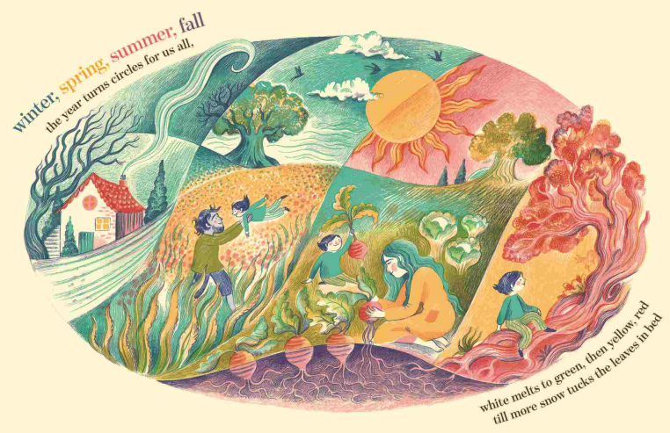
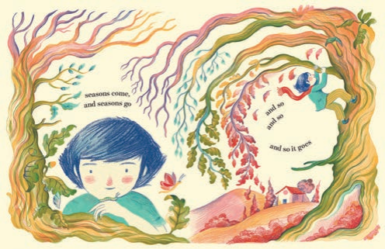

请将反馈信息发至：版权负责人
Email：Rights@nurnberg.com.cn
安德鲁·纳伯格联合国际有限公司北京代表处
北京市海淀区中关村大街甲59号中国人民大学文化大厦1705室, 邮编：100872
电话：010-82504106, 传真：010-82504200
公司网址：http://www.nurnberg.com.cn
书目下载：http://www.nurnberg.com.cn/booklist_zh/list.aspx
书讯浏览：http://www.nurnberg.com.cn/book/book.aspx
视频推荐：http://www.nurnberg.com.cn/video/video.aspx
豆瓣小站：http://site.douban.com/110577/
新浪微博：安德鲁纳伯格公司的微博_微博 (weibo.com)
微信订阅号：安德鲁纳伯格联合国际北京代表处

